**Task Description**

The task includes -

* Launch AWS EC2 Linux instance and connect it using SSH using PuTTY
* Installing Apache server on a Linux machine

About **Apache Server** :

* **Apache is the most commonly used Web server on Linux systems.** Web servers are used to serve Web pages requested by client computers. Clients typically request and view Web pages using Web browser applications such as Firefox, Opera, Chromium, or Internet Explorer.
* **Apache HTTP Server is a free and open-source web server** that delivers web content through the internet. It is commonly referred to as Apache and after development, it quickly became the most popular HTTP client on the web.

About **PuTTY and PuTTYgen** :

* PuTTY is a free implementation of SSH and Telnet for Windows and Unix platforms, along with an xterm terminal emulator.
* PuTTYgen is a key generator tool for creating pairs of public and private SSH keys. It is one of the components of the open-source networking client PuTTY.

**Screenshots of the tasks :**

* Creating AWS EC2 Linux Instance

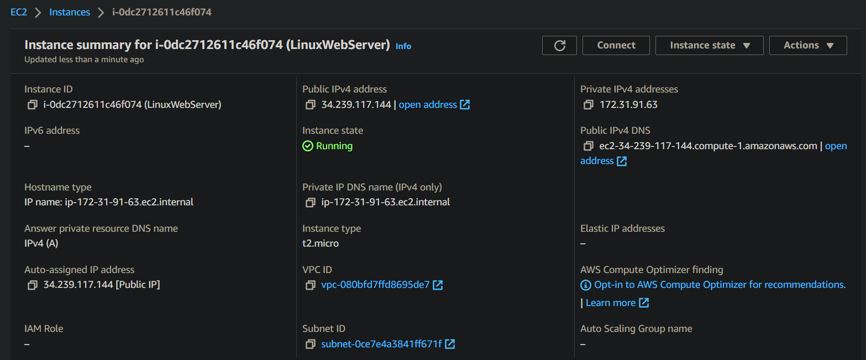

Successfully created EC2 instance with desired configuration.

* Security Configuration

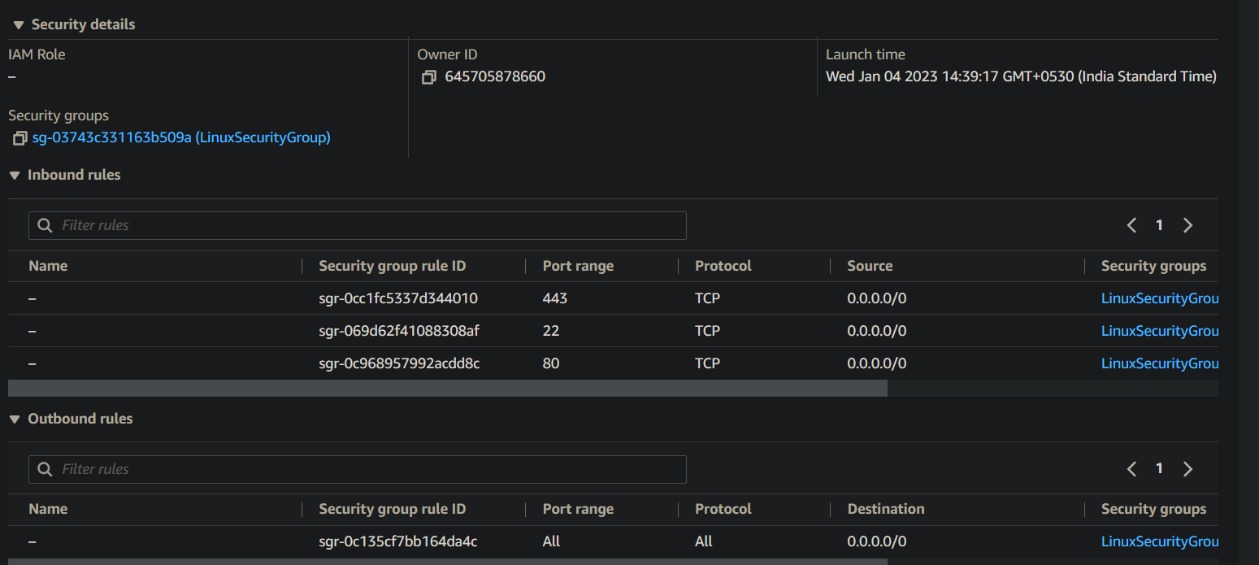

Successfully created security groups.

* Networking Configuration :

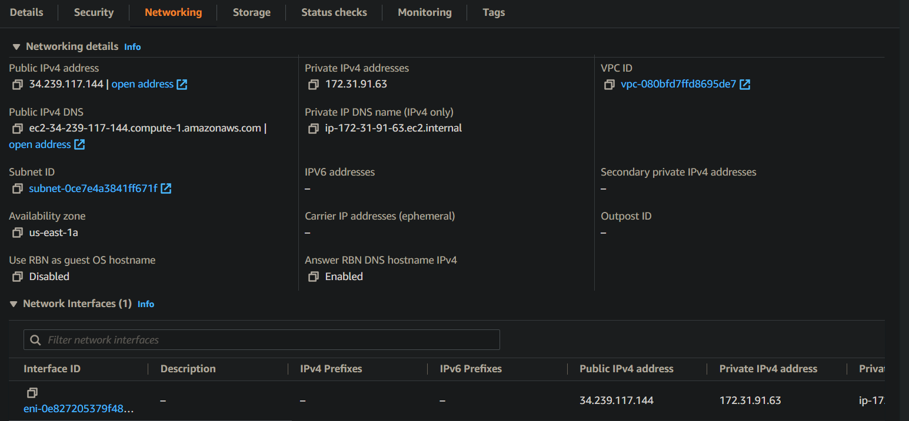

Successfully configured networking details.

* Establishing connection with EC2 instance :

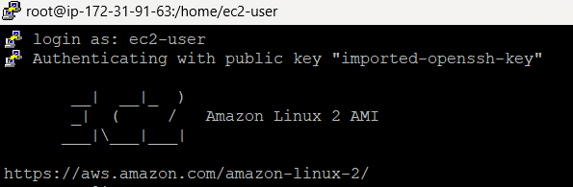

Successfully connected with EC2 instance using PuTTY

* Installing Apache Web Server on Linux Machine using SSH using PuTTY :

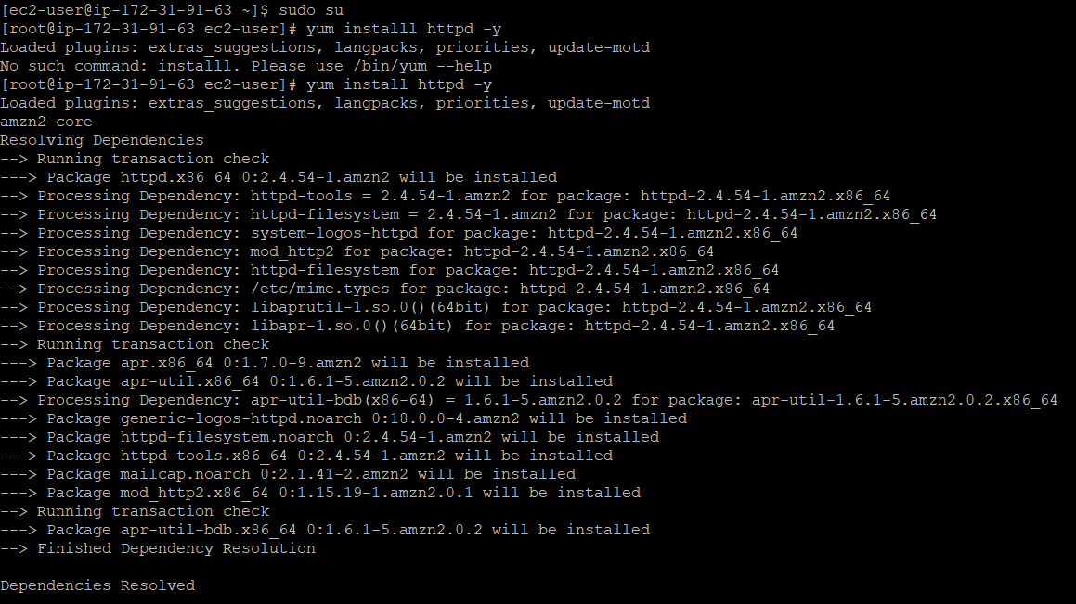

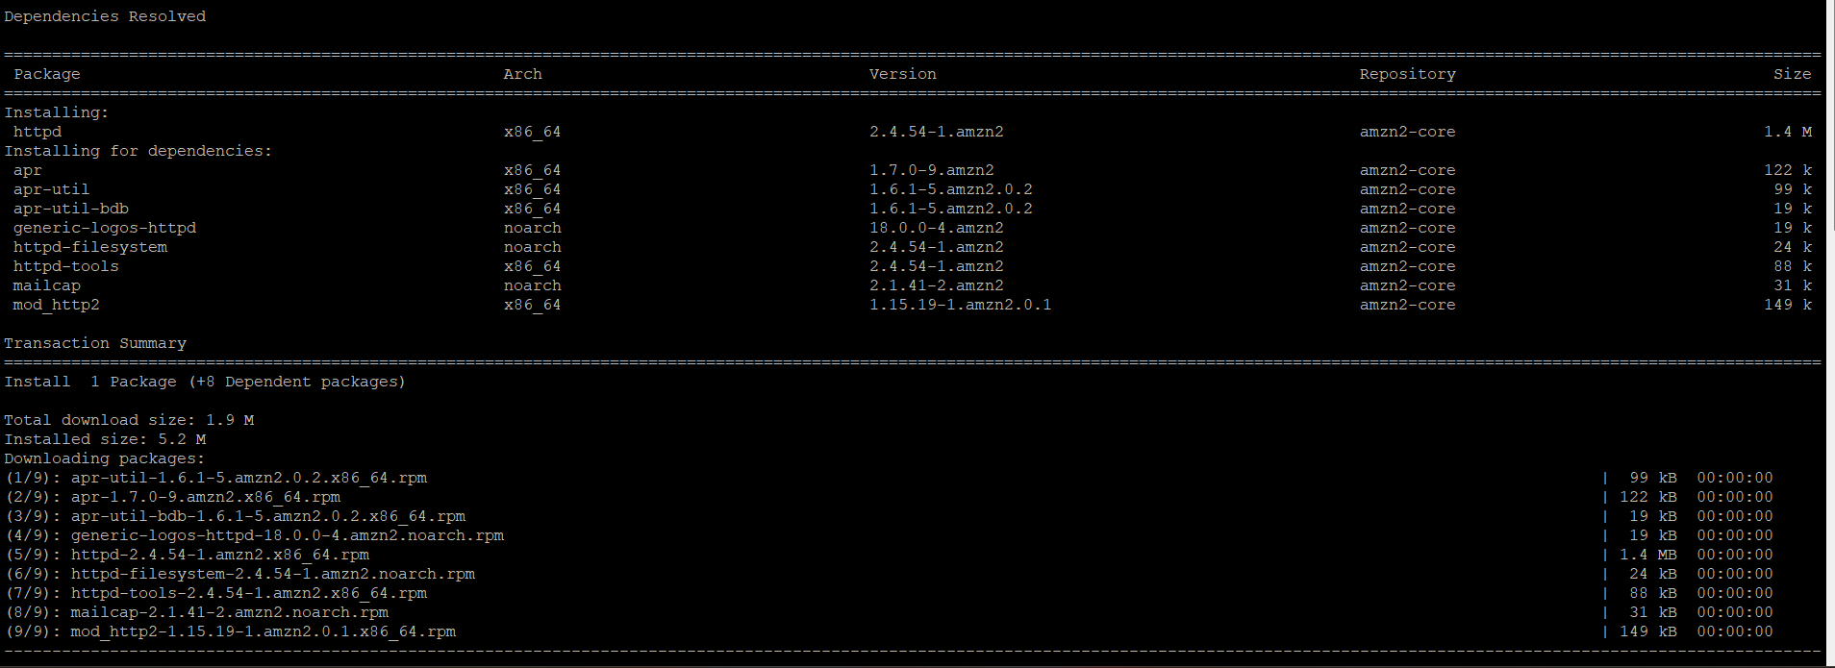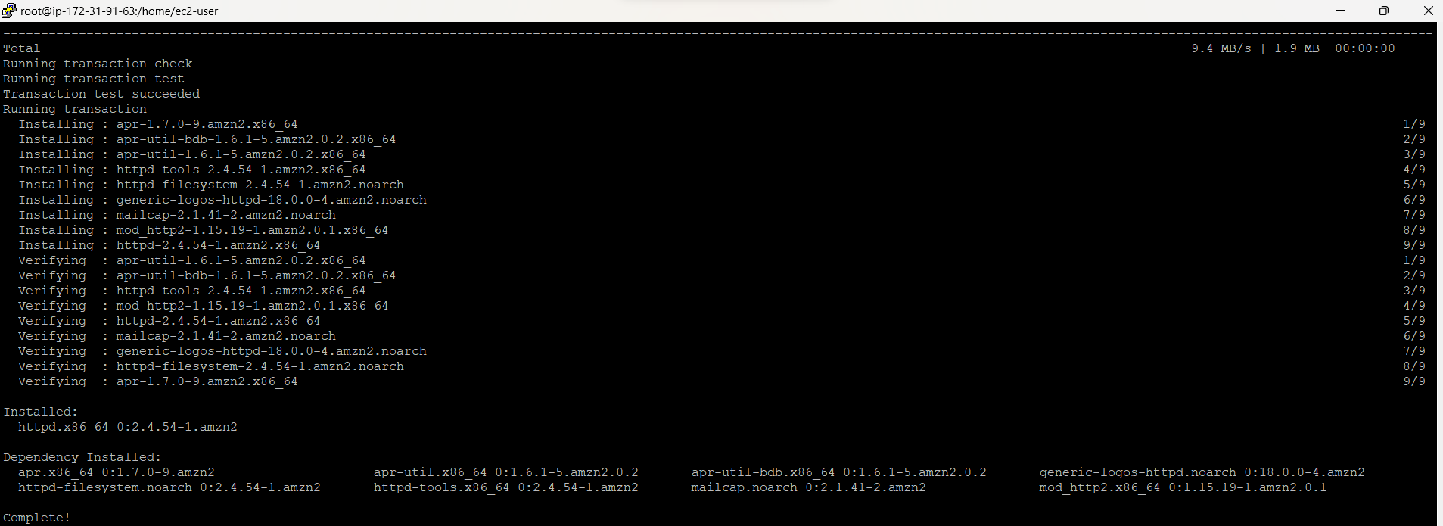

* Checking Status of Apache Web Server and making it active :

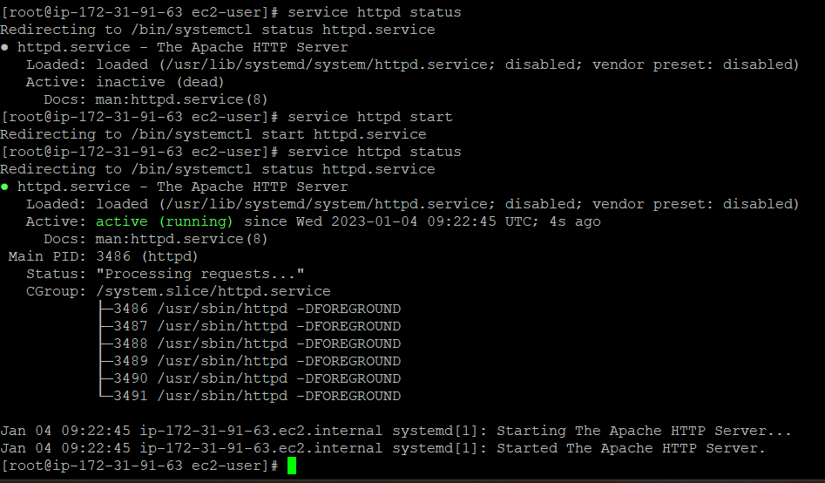

* FInally Apache Web Server :

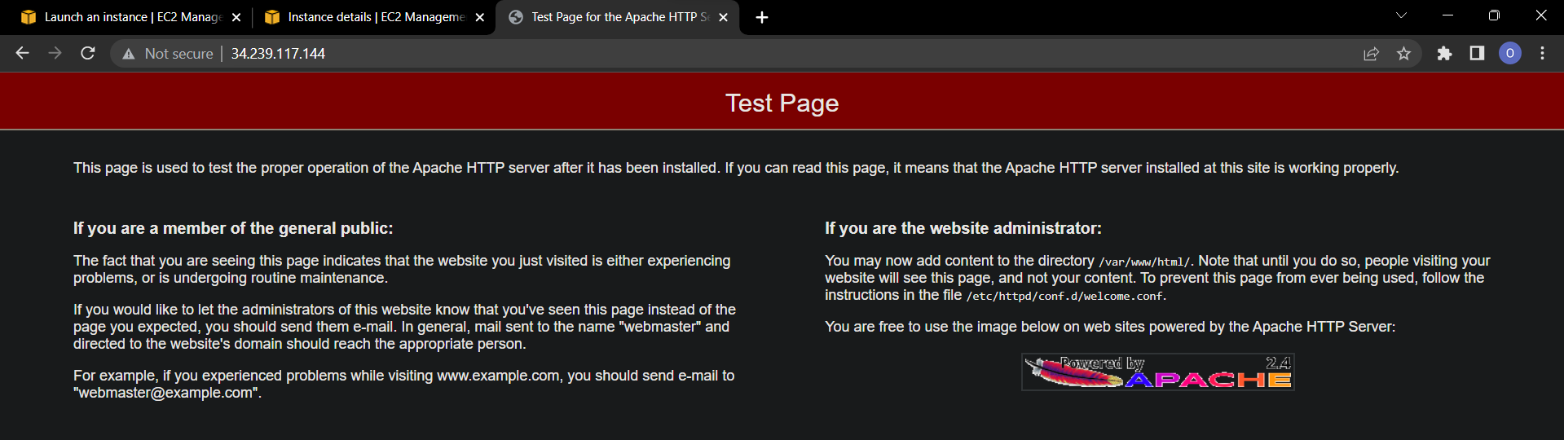

Successfully completed the task!

**Here’s IP of my task**

**34.239.117.144 [Public IP]**

THANK YOU!!